**PRACTICAL NO: 5**

**AIM:** Create simple Adhoc network.

**Step 1:** Go to omnetpp-5.5.1 folder in which open “mingwenv.cmd” file, we get following window. Type “./configure” and “make” command for further installation. 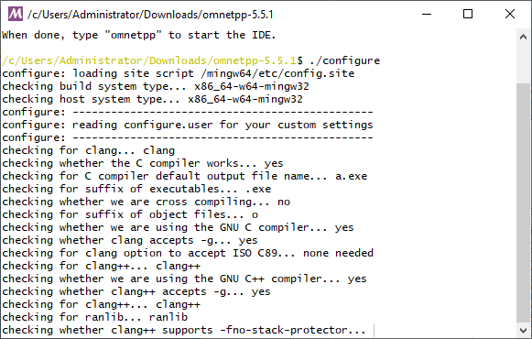

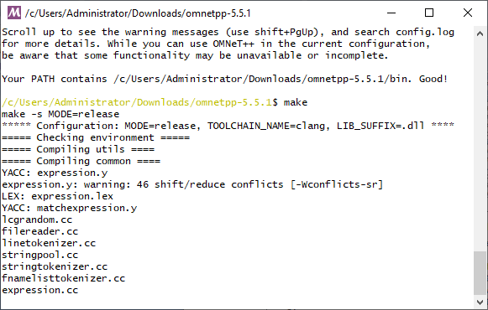

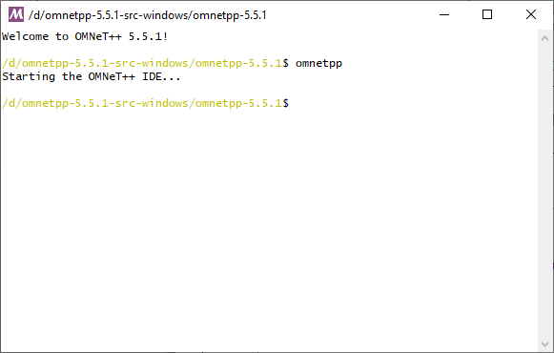**Step 2:** Go to omnetpp-5.5.1 folder in which open “mingwenv.cmd” file, we get following window. Type “omnetpp” command to open omnet++ IDE.

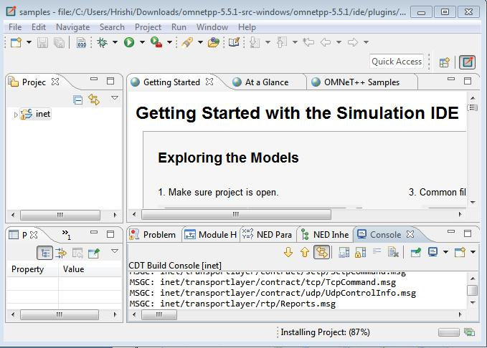**Step 3:** after that command, following window will open.

**Step 4:** Go to project Explorer > inet > examples > Adhoc > Hostautoconf and open Scenario.nedfile.

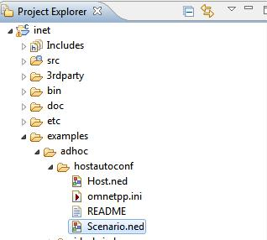

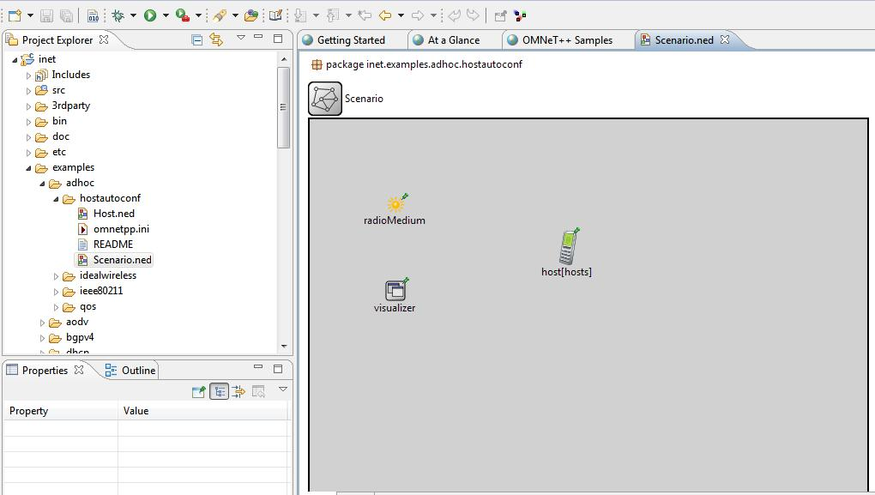**Scenario.ned:**

**Coding:**

**Scenario.ned:**

package inet.examples.adhoc.hostautoconf;

import inet.physicallayer.ieee80211.packetlevel.Ieee80211ScalarRadioMedium;

import inet.visualizer.contract.IIntegratedVisualizer; network Scenario

{

parameters:

int hosts;

@display("bgb=650,450");

submodules:

visualizer: <default("IntegratedCanvasVisualizer")> like IIntegratedVisualizer if hasVisualizer() {

parameters:

@display("p=100,200;is=s");

}

radioMedium: Ieee80211ScalarRadioMedium

{

parameters:

@display("p=100,100;is=s");

}

host[hosts]: Host

{

@display("p=300,150");

}

}

**Omnetpp.ini:**

[General]

*#debug-on-errors = true*

*#record-eventlog = true*

network = Scenario

sim-time-limit = 60min

cmdenv-express-mode = **true**

*.hosts = 3

**.constraintAreaMinX = 0m

**.constraintAreaMinY = 0m

**.constraintAreaMinZ = 0m

**.constraintAreaMaxX = 600m

**.constraintAreaMaxY = 400m

**.constraintAreaMaxZ = 0m

*# mobility*

**.host*.mobility.typename = "MassMobility"

**.host*.mobility.initFromDisplayString = **false**

**.host*.mobility.changeInterval = truncnormal(2s, 0.5s)

**.host*.mobility.angleDelta = normal(0deg, 30deg)

**.host*.mobility.speed = truncnormal(20mps, 8mps)

**.host*.mobility.updateInterval = 100ms

**.host*.ac_wlan.interfaces = "wlan0"

*UdpBasicApp / UdpSink* **.host*.numApps = 1 **.app[0].typename = "UdpBasicApp" **.app[0].destAddresses = "host[0]" **.app[0].localPort = 9001 **.app[0].destPort = 9001 **.app[0].messageLength = 100B **.app[0].startTime = uniform(10s, 30s) **.app[0].sendInterval = uniform(10s, 30s)

*nic settings*

**.wlan[*].bitrate = 2Mbps

**.wlan[*].mgmt.frameCapacity = 10

**.wlan[*].mac.retryLimit = 7

**.wlan[*].mac.dcf.channelAccess.cwMin = 7

**.wlan[*].mac.cwMinBroadcast = 31

**.wlan[*].radio.transmitter.power = 2mW

**.wlan[*].radio.receiver.sensitivity = -85dBm

**.wlan[*].radio.receiver.snirThreshold = 4dB

**.udpapp.*.vector-recording = **true**

**.vector-recording = **true**

**Step 5:** Click on Run button.

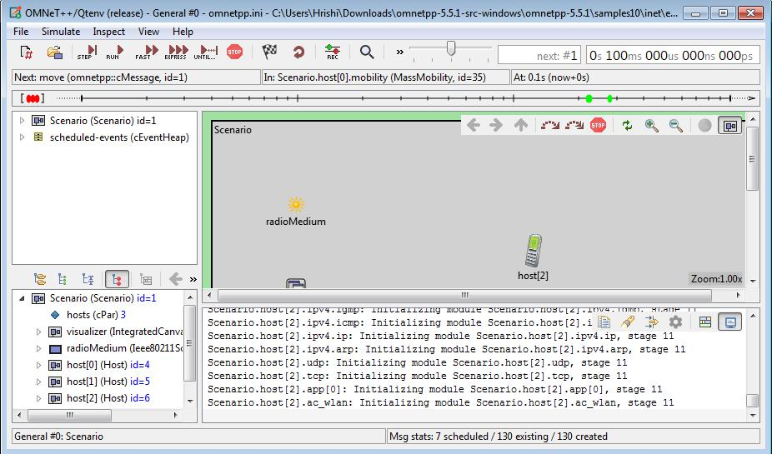**Step 6:** After that following window will open.

**Step 7:**Click on RUN.

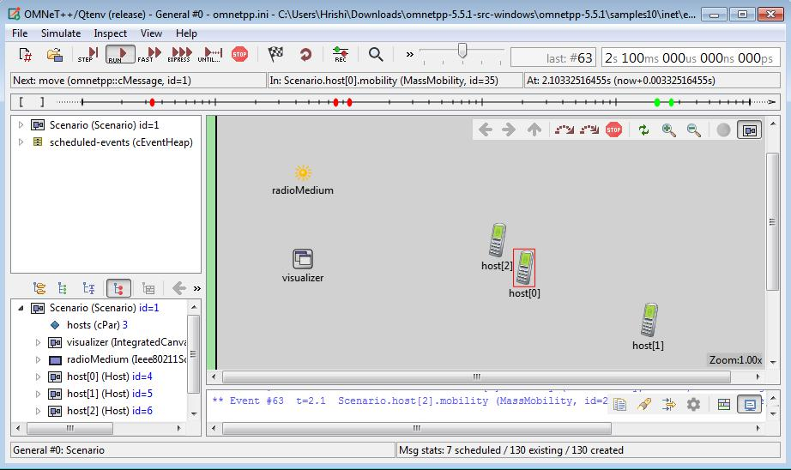

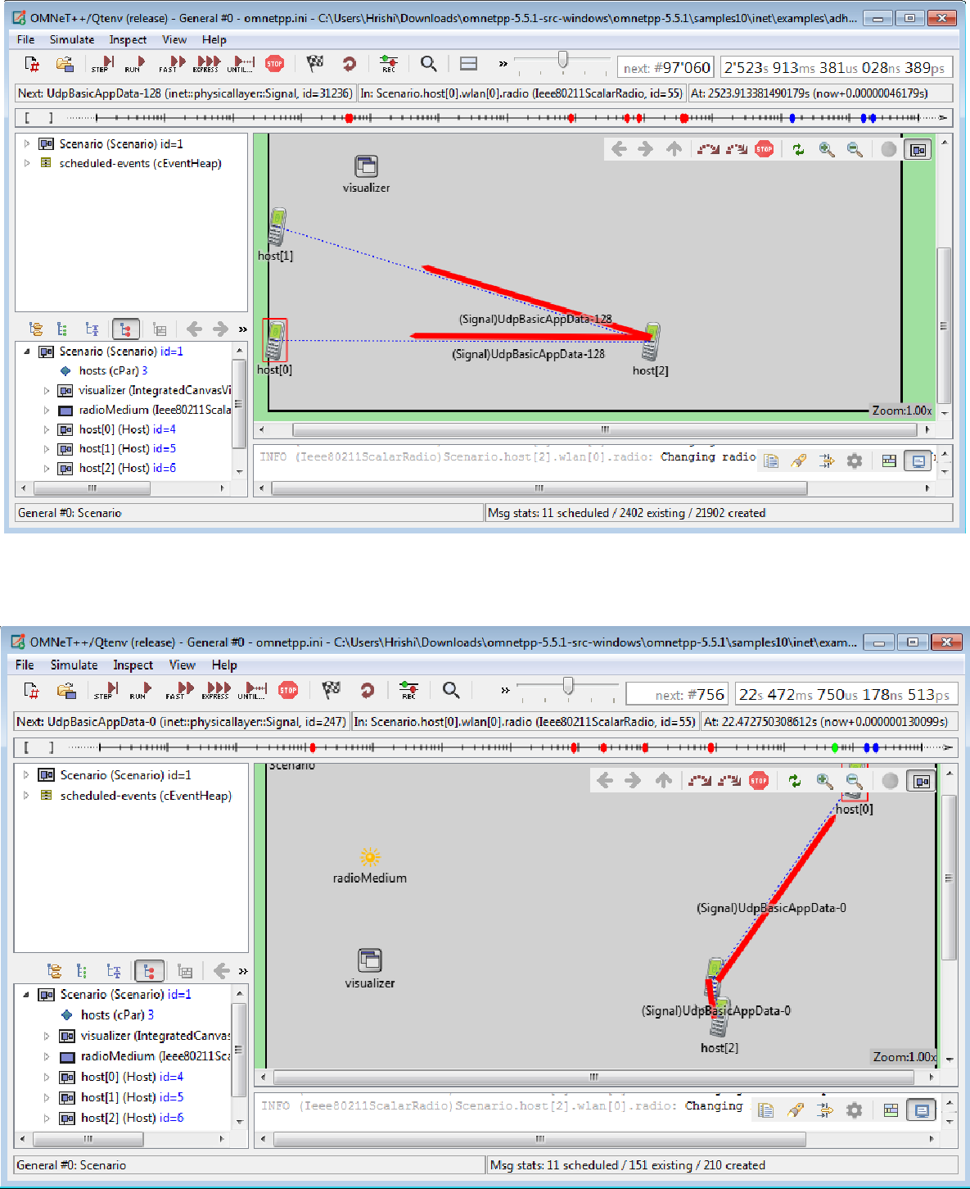**OUTPUT:**

**Conclusion:** We have learnt to create a simple ADHOC network.